Question 1

A: The answer can be seen in figure below.

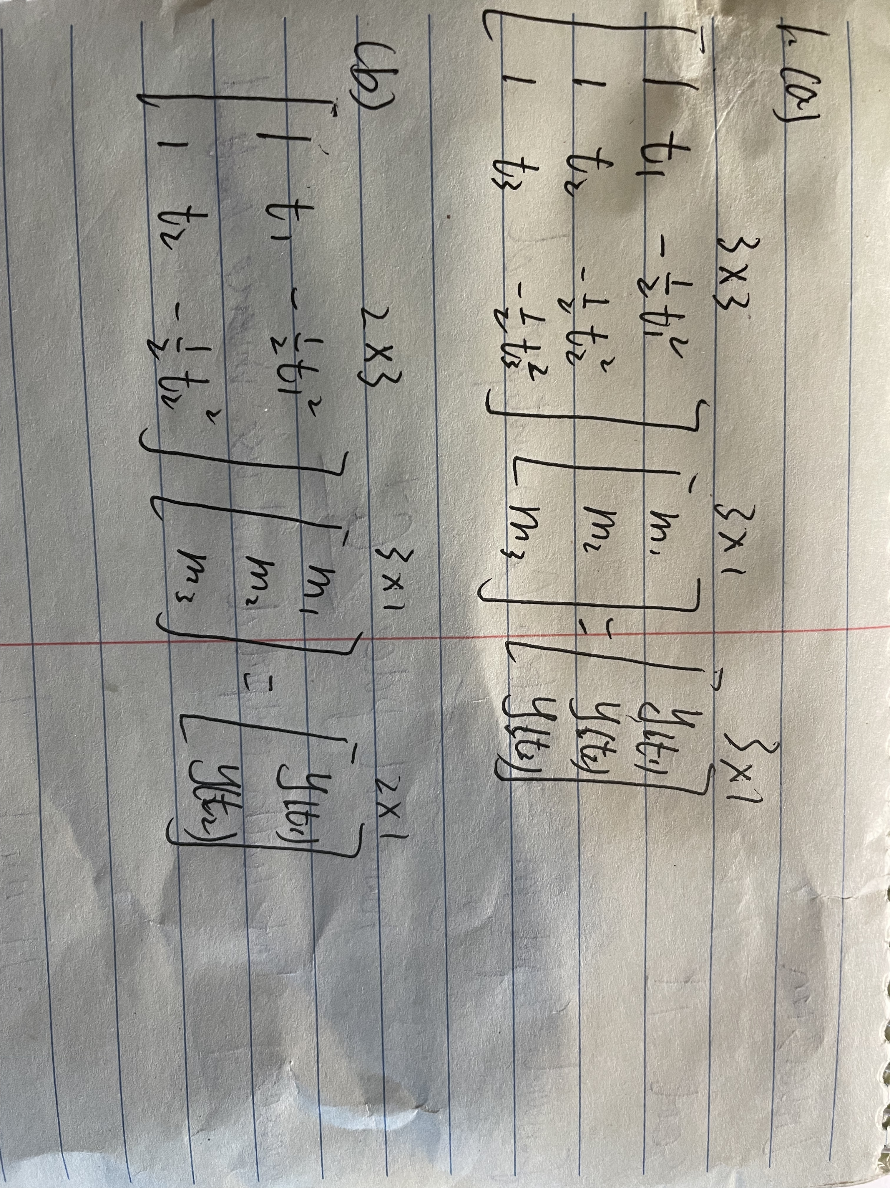

Question 2

1. A: Basically, dnoise and dtrue have similar trend but the variation in dnoise is much higher.



Figure 1. The comparison between dnoise and dtrue.

1. A: yestimation and ytrue have a similar trend generally. About t = 0 to 1, the difference between yestimation and ytrue seems not very large. Then between t=1 to 2.5, the difference become larger and after t=2.5, it seems become smaller.



Figure 2. The comparison between yestimation and ytrue

**Codes**:

|  |
| --- |
| clear  %% solving for (a)  m_true = [0.18;16.21;9.81];  t = linspace(0,3,20)';  G = [ones(20,1),t,-1/2*t.^2];  d_true = G*m_true;  d_noise = d_true + 2*randn(20,1);  figure(1)  plot(t,d_true,'o','MarkerSize',8)  hold on  plot(t,d_noise,'*','MarkerSize',8)  xlabel('t')  ylabel('y')  legend('d_{True}','d_{noise}')  set(gca,'fontsize',16)  %% solving for (b)  m_est = G\d_noise;  figure(2)  plot(t,G*m_true,'-.','LineWidth',2)  hold on  plot(t,G*m_est,'--','LineWidth',2)  xlabel('t')  ylabel('y')  legend('y_{True}','y_{Estimation}')  set(gca,'fontsize',16) |